WEST LONDON WASTE AUTHORITY
Report of the Waste Minimisation Manager | 20 September 2019
Waste Minimisation Update

SUMMARY
This report provides an update on the Authority’s Waste Minimisation activities.

RECOMMENDATION(S)
The Authority is asked to:
Note the information within this report.

- Introduction – The Waste Minimisation Team delivers the campaigns that focus on minimising the seven key waste streams of food, textiles, waste electrical and electronic equipment, nappies, bulky household waste, plastics and dry mixed recycling. The team is also responsible for the Authority’s website, intranet, social media, and media communications.

- Key waste streams
  - Food Waste
    - The average recycling collection of food waste across 516 flatted properties in Richmond, ten months after its initial service commencement is approximately 0.455kg per property per week. The revised target of the project is to collect 1 to 1.5kg per property per week to ensure robust return on investment. To attract new customers and encourage existing service users, the team delivered a second round of liners and leaflets on the 8th, 9th and 12th of August and appointed one round of communal food waste bin cleaning which took place on the 10th of August. A second round of cleaning will take place on the 2nd of November 2019. In addition, starting from the 1st of October, the team will tour the estates to engage with residents during high footfall timings to encourage food waste recycling quality and participation. The second phase of the project will bring on an additional 700 flats onto food waste recycling service in October 2019.

    - The team is working closely with Hounslow and Ealing Council to introduce food waste recycling service and utilise bin sensors to monitor activities across different waste streams and to drive collection efficiencies in November to pre-selected estates.
    - The team is currently in negotiation and is working out a schedule to deliver educational programs and resources to support the introduction of food waste recycling at schools.

  - WEEE
    - WLWA and Harrow Council will be launching a combined on-request home collection of textiles and WEEE with Traid in October 2019.
    - The difference in WEEE tonnage between 2018 and 2019 is minimal and the team is continuously working with borough partners to explore various collection methodologies to increase WEEE capture. As it stands, the authority is capturing approximately 2.5kg of WEEE per household per year.

Textiles
    - The team is focusing on increasing the capture rate of textiles and to provide as many options for residents to reuse and recycle unwanted textiles to achieve overall waste disposal savings.

On-request home textile collections operated by Traid from from January till September as compared to the previous year increased from 577 to 898 requests weight by 35.7% collectively across Richmond, Brent and Harrow. To date, the team delivered four clothes and shoes swapping events and four Repair Cafes across Brent and Richmond collectively. Harrow Council officially launched the on-request home textile collection service carried out by Traid in April and is seeing tripling of incoming requests since. Textile related engagement activities will also cover Harrow September onwards.

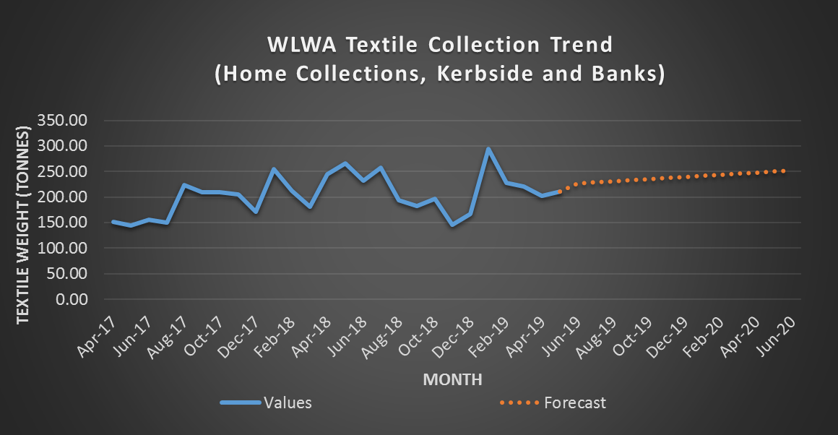

    - The textile recycling industry is experiencing hardship because of fast fashion and the vast yield of poor quality shoes and clothes collected for reuse and recycling. End markets are reaching capacity and are shifting to profit from higher-valued streams, such as WEEE instead. Small-scale textile recyclers are continuously looking for ways to collect higher quality textiles to justify financial viability. As a result, LMB and JMP Wilcox are withdrawing kerbside contracts for textiles recycling across West London. Local councils must focus more on increasing the capture rate of textiles in contracts instead of the decreasing revenue. Contracts that offer high income for textiles are not sustainable and would decrease throughout the contract period. This method of contract selection could lead to a monopoly on the textile recycling market.

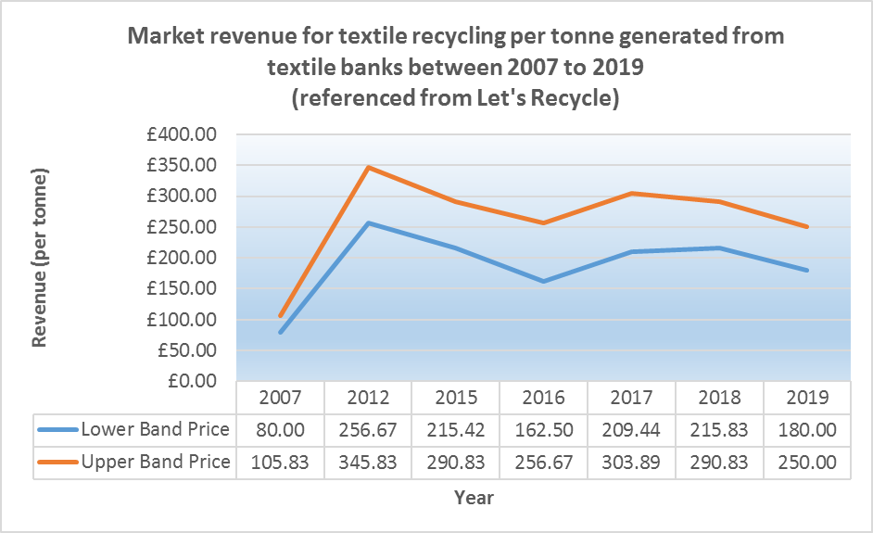

  - Reusable Nappies
    - The uptake of the reusable nappies scheme increased from January to July with 65 incoming applications during 2018 to 141 in 2019. The projection of applications will increase from 152 applications requested during 2018 to 260 applications in 2019. The team will also expand on the work by introducing alternative feminine hygiene products to tackle single-use plastic waste.
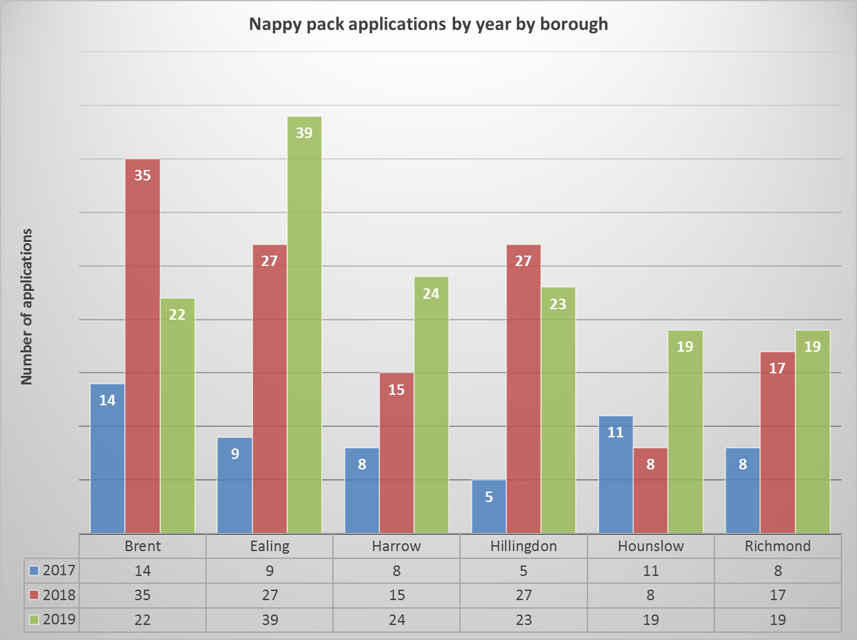
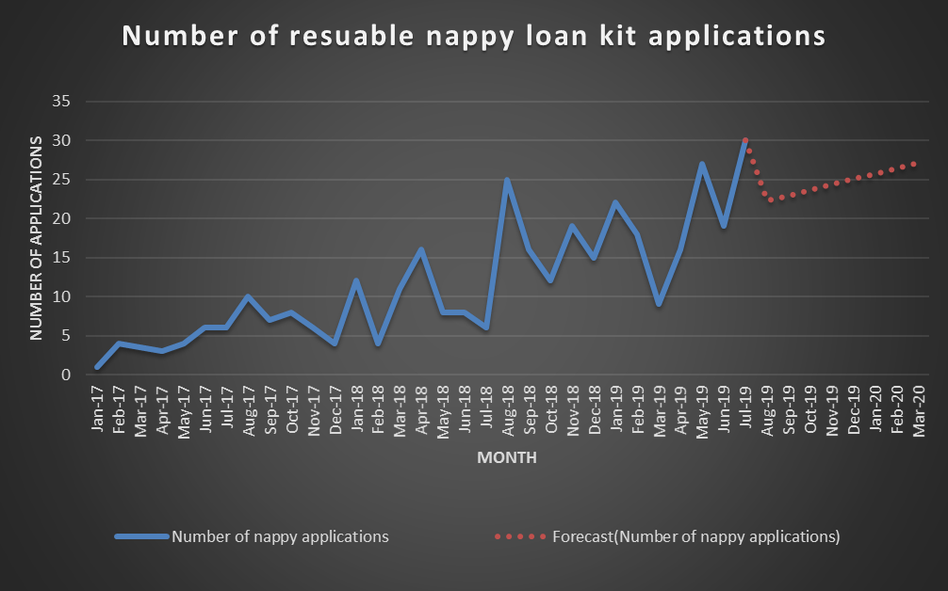

  - Communications
    - WLWA is assisting Richmond Council to promote a new consultation and engagement programme in September. Being part of a video series for Richmond’s Climate Change Summit, WLWA spoke about the real impact of waste and the need for collective behavioural change.
    - WLWA will be a key speaker at the Recycling Waste Management Show on the 12th of September to voice the authority’s position and action to influence national policy on food waste recycling. Towards the end of September, WLWA will also present independent findings and challenges of recycling plastics at the Plastics Recycling and Resources Conference hosted by RECycling Of Used Plastics Limited (RECOUP).
    - The Authority will submit two applications to showcase the newly improved Health & Safety practises and reporting for the EDIE and Local Government Chronical awards.
    - The team delivered 34 events so far during this financial year and engaged with 1823 people, which includes a mixture of nappy handovers, compost giveaways, information stalls, repair cafes, and workshops. So far, the team confirmed nine further events with an additional 15 in the planning.
    - Due to the launch of the upcycled wedding dress competition, WLWA’s website saw a sharp increase in view count during May 2019; however, it is experiencing a decrease since.
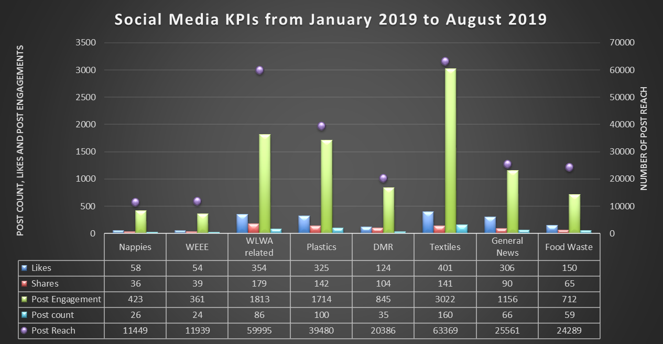

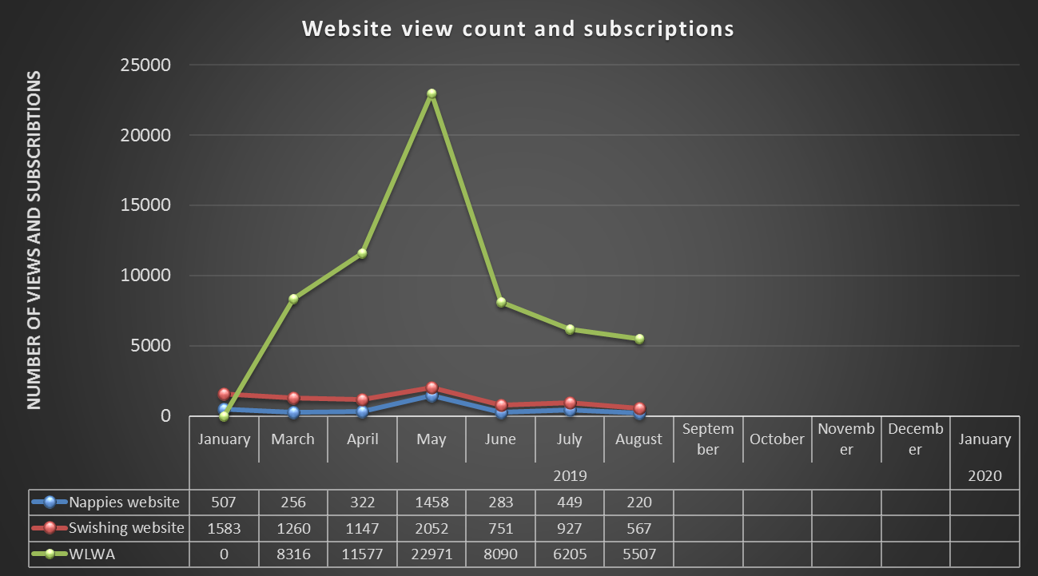

General;
    - The Waste Minimisation programme is on track.
Contact Officers | Mildred Jeakins, Waste Minimisation Manager  mildredjeakins@westlondonwaste.gov.uk | 01895 546 623
 | Emma Beal, Managing Director  emmabeal@westlondonwaste.gov.uk | 01895 545 515

